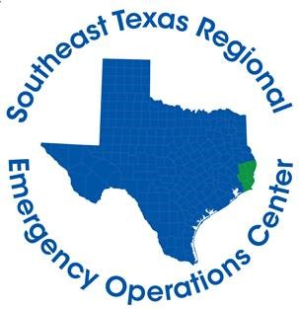

Hardin County Judge Wayne McDaniel
Jasper County Judge Mark Allen
Jefferson County Judge Jeff Branick
Newton County Judge Kenneth Weeks
Orange County Judge John Gothia
Tyler County Judge Jacques Blanchette

FOR IMMEDIATE RELEASE CONTACT: DAVILYN WALSTON
WEDNESDAY, APRIL 1, 2020 PUBLIC AFFAIRS OFFICER
CELL: (409) 553-9881
April 1st Daily Briefing

BEAUMONT, Texas – The following information from the Southeast Texas Regional Emergency Operations Center summarizes activities and developments related to COVID-19 in Hardin, Jasper, Jefferson, Newton, Orange, and Tyler counties:
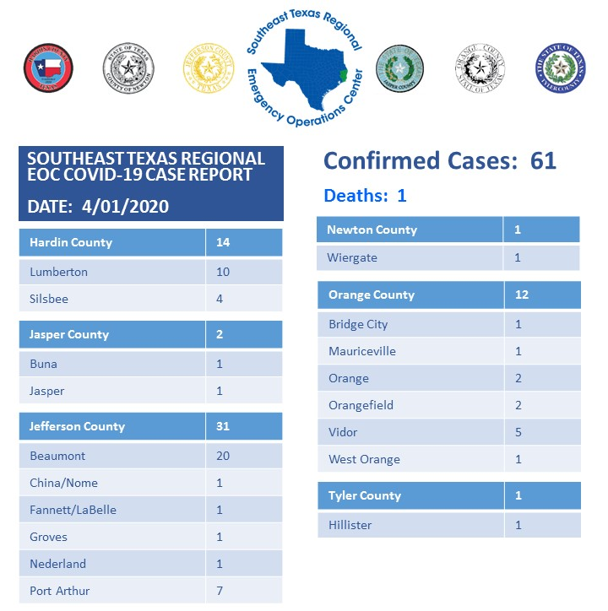
*The March 31st Briefing inaccurately reported two (2) cases for Tyler County instead of one (1).
Total calls received by Call Center – 1,938
- 172 calls received today
- 927 have been referred for testing since call center opened on 3/20)
- 82 were tested at the drive-through site today in Jefferson County
- 33 were tested at the drive-through site today in Hardin County
If you are experiencing symptoms (fever, dry cough, shortness of breath) or you believe you have been exposed to an infected individual, you can call 409-550-2536 to be evaluated for testing. The Call Center is open 24-hours, seven days a week.
If you are looking for information about COVID-19, please do not call the Call Center. You can call 211 option 6 or visit SETINFO.ORG.
There will not be a Question-and-Answer session today.

